

**UNIVERSITI MALAYSIA TERENGGANU**

**CSM3103 – FRONT-END PROGRAMMING**

**BACHELOR OF COMPUTER SCIENCE (MOBILE COMPUTING) WITH HONORS**

**LAB 5**

**SEMESTER II 2023/2024**

**Prepared for:**

DR RABIEI BIN MAMAT

**Prepared by:**

MUHAMMAD ARIF HAIKAL BIN SALLEHUDDIN

(S66355)

**Link Github :**

[**https://github.com/arifhaikal2001/CSM3103-LAB-5.git**](https://github.com/arifhaikal2001/CSM3103-LAB-5.git)

**Task 1**

Code :

|  |
| --- |
| <html>  <head>  <title>Lab 5 : Task 1</title>  <meta charset="utf-8">  <script  src="https://code.jquery.com/jquery-3.1.1.js"  integrity="sha256-16cdPddA6VdVInumRGo6IbivbERE8p7CQR3HzTBuELA="  crossorigin="anonymous"></script>  <link rel="stylesheet" href=  "https://cdnjs.cloudflare.com/ajax/libs/mini.css/2.0.2/mini-default.css">  <style>  body { margin: 20px; }  #color_change { border: 1px solid; }  .cow_color { font-weight: bold; }  </style>    <script>  $(document).ready(function() {  var button = $('#button_change');    $(button).click(function(){    var input_color = $('#input_color');  var input_value = $(input_color).val();  var element = $('.door_color');  $(element).html(input_value);  $('body').css('color', input_value);  });  });  </script>  </head>  <body>    <h2> Paint it <span class="door_color">Black</span> by The Rolling Stones(1966)</h2>  <p>I see a red door and I want it painted <span class="door_color">Black</span>  </p>  <p>My Wanted Color is :  <input id="input_color" value="Purple"></input>  <button id="button_change">  Change!  </button>  </p>  </body>  </html> |

Output:

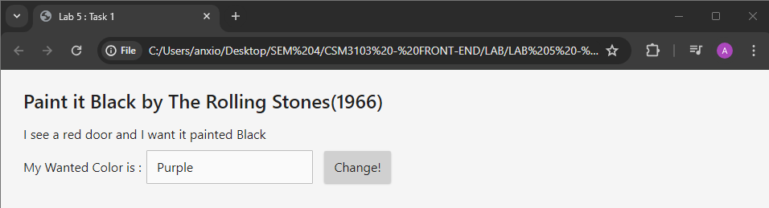

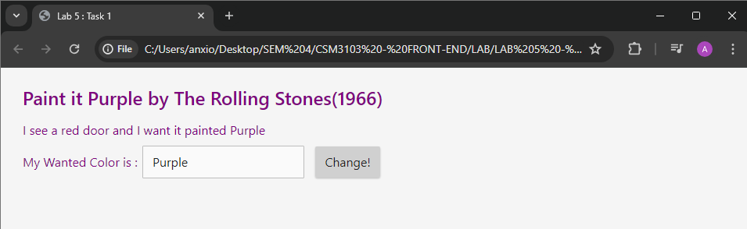

For selected colour

Code :

|  |
| --- |
| <html>  <head>  <title>Lab 5 : Task 1 - select colour</title>  <meta charset="utf-8">  <script  src="https://code.jquery.com/jquery-3.1.1.js"  integrity="sha256-16cdPddA6VdVInumRGo6IbivbERE8p7CQR3HzTBuELA="  crossorigin="anonymous"></script>  <link rel="stylesheet" href=  "https://cdnjs.cloudflare.com/ajax/libs/mini.css/2.0.2/mini-default.css">  <style>  body { margin: 20px; }  #color_change { border: 1px solid; }  .cow_color { font-weight: bold; }  </style>    <script>  $(document).ready(function() {  $('#button_change').click(function(){  var selectedColor = $('#select_color').val();  $('.door_color').html(selectedColor);  $('.door_color').css('color', selectedColor);  });  });  </script>  </head>  <body>    <h2> Paint it <span class="door_color">Black</span> by The Rolling Stones(1966)</h2>  <p>I see a red door and I want it painted <span class="door_color">Black</span>  </p>  <p>My Wanted Color is :  <select id = "select_color">  <option value ="black">Black</option>  <option value ="red">Red</option>  <option value ="green">Green</option>  <option value ="blue">Blue</option>  <option value ="purple">Purple</option>    </select>  <button id="button_change">  Change!  </button>  </p>  </body>  </html> |

Output :

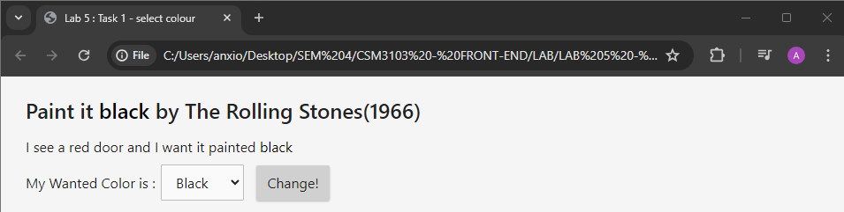

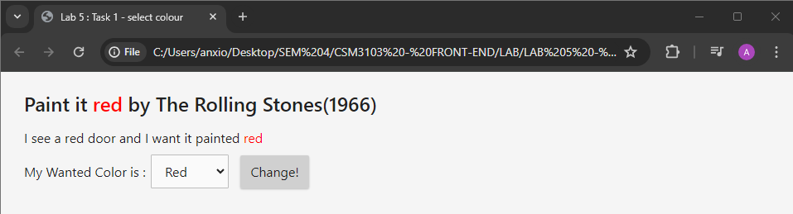

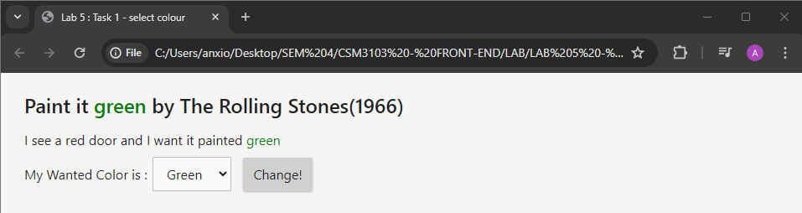

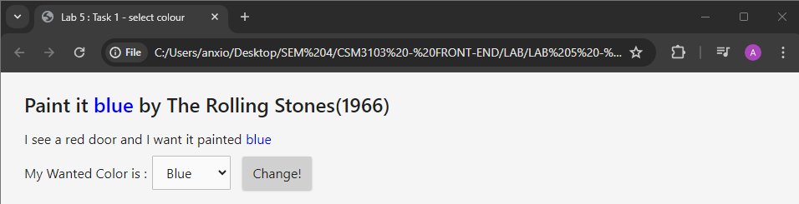

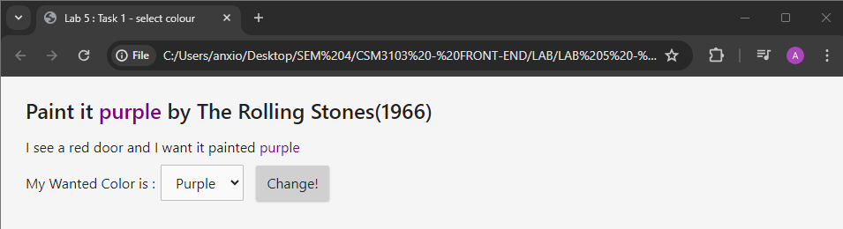

**Task 2**

Code :

|  |
| --- |
| <!doctype html>  <html>  <head>  <title>Lab 5: Task 2</title>  <meta charset="utf-8">  <link rel="stylesheet" href=  "https://maxcdn.bootstrapcdn.com/bootstrap/3.3.7/css/bootstrap.min.css">  <style>  #boxes { margin-top: 50px; float: left; width: 100%; }  #toggles { float: left; width: 100%; margin-top: 10px; }  #info { float: left; margin-top: 5px; }  .box { width: 50px; height: 50px; float: left; }  .outlined { border: 2px solid black; }  .round-edge { border-radius: 15px; }  .teal { background-color: teal; }  </style>  <script  src="https://code.jquery.com/jquery-3.1.1.js"  integrity="sha256-16cdPddA6VdVInumRGo6IbivbERE8p7CQR3HzTBuELA="  crossorigin="anonymous"></script>  <script>  var colorTeal = "rgb(57, 204, 204)";  $(document).ready(function(){  var colorTeal = "rgb(57, 204, 204)";  var originalBackgroundColor = "";  $('#button_toggle_colors').click(function(){  // Check the background color of the first box to determine the current state  var box1 = $('#box1');  if (originalBackgroundColor === "") {  // Save the original background color if it hasn't been saved yet  originalBackgroundColor = $(box1).css('background-color');  }  // Toggle background color of all boxes  $('.box').each(function(){  if ($(this).css('background-color') === colorTeal) {  $(this).css('background-color', originalBackgroundColor);  } else {  $(this).css('background-color', colorTeal);  }  });  });  $('#button_toggle_roundedges').click(function(){  $(".box").toggleClass('round-edge');  });  $('#button_add_box').click(function(){  // Create a new box and append it to the boxes container  var newBox = $('<div class="box outlined"></div>');  $('#boxes').append(newBox);  });  });  var new_box = document.createElement('div');  var existingBoxes = $(".box").length;  var nextBoxId = existingBoxes+1;  $(new_box).attr("id","box"+nextBoxId);  $(new_box).addClass("box");  $(new_box).addClass("outlined");  $("#boxes").append(new_box);    </script>  </head>  <body>  <div class="container">  <div id="boxes">    <div id="box1" class="box outlined"></div>  <div id="box2" class="box outlined"></div>  <div id="box3" class="box outlined"></div>  </div>  <div id="toggles">  <h2>Toggles</h2>  <button class="btn" id="button_toggle_colors"  >Toggle Colors</button>  <button class="btn" id="button_toggle_roundedges"  >Toggle Rounded Borders</button>  <button class="btn" id="button_add_box"  >Add a New Box</button>  </div>    </div>  </body>  </html> |

Output :

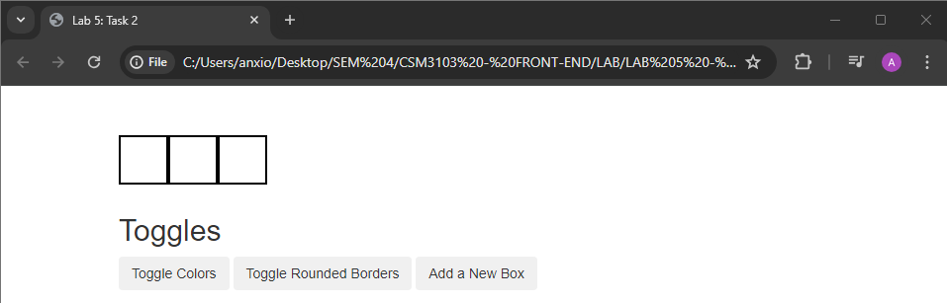

Toggle colour

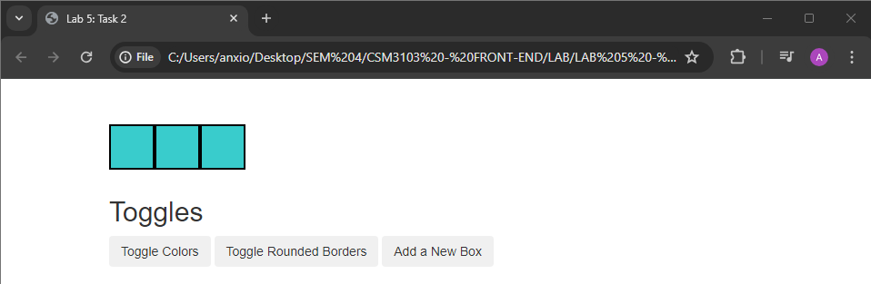

Toggle Rounded Borders

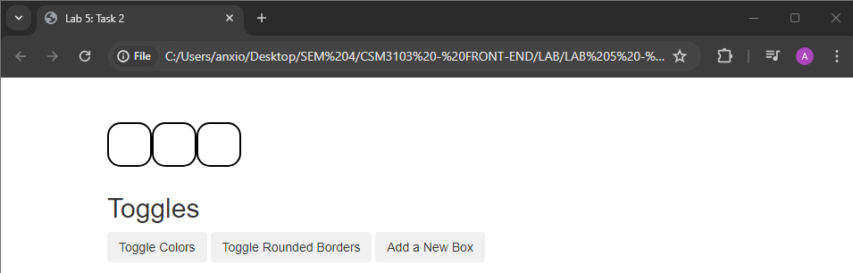

Add a New Box

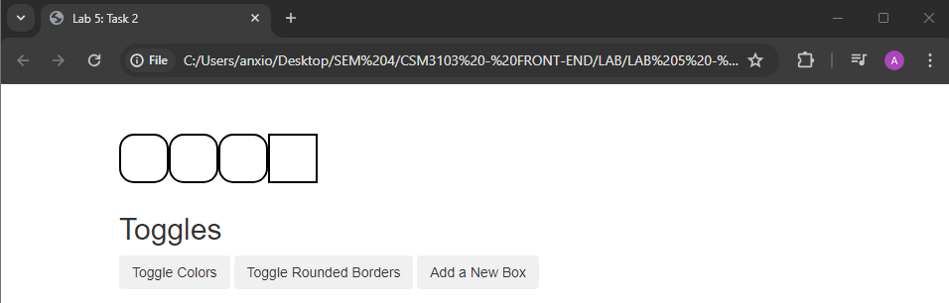

Modify

Code :

|  |
| --- |
| <!doctype html>  <html>  <head>  <title>Lab 5: Task 2 - Modify</title>  <meta charset="utf-8">  <link rel="stylesheet" href="https://maxcdn.bootstrapcdn.com/bootstrap/3.3.7/css/bootstrap.min.css">  <style>  #boxes { margin-top: 50px; float: left; width: 100%; }  #toggles { float: left; width: 100%; margin-top: 10px; }  #info { float: left; margin-top: 5px; }  .box { width: 50px; height: 50px; float: left; }  .outlined { border: 2px solid black; }  .round-edge { border-radius: 15px; }  .teal { background-color: teal; }  </style>  <script src="https://code.jquery.com/jquery-3.1.1.js" integrity="sha256-16cdPddA6VdVInumRGo6IbivbERE8p7CQR3HzTBuELA=" crossorigin="anonymous"></script>  <script>  $(document).ready(function(){  var colorTeal = "rgb(57, 204, 204)";  var originalBackgroundColor = "";  $('#button_toggle_colors').click(function(){  // Check the background color of the first box to determine the current state  var box1 = $('#box1');  if (originalBackgroundColor === "") {  // Save the original background color if it hasn't been saved yet  originalBackgroundColor = $(box1).css('background-color');  }  // Toggle background color of all boxes  $('.box').each(function(){  if ($(this).css('background-color') === colorTeal) {  $(this).css('background-color', originalBackgroundColor);  } else {  $(this).css('background-color', colorTeal);  }  });  });  $('#button_toggle_roundedges').click(function(){  $(".box").toggleClass('round-edge');  });  $('#button_add_box').click(function(){  // Hide all existing boxes  $(".box").hide();  // Randomly select one box to show  var randomBoxIndex = Math.floor(Math.random() * $(".box").length);  $(".box").eq(randomBoxIndex).show();  });  });  </script>  </head>  <body>  <div class="container">  <div id="boxes">  <div id="box1" class="box outlined"></div>  <div id="box2" class="box outlined"></div>  <div id="box3" class="box outlined"></div>  </div>  <div id="toggles">  <h2>Toggles</h2>  <button class="btn" id="button_toggle_colors">Toggle Colors</button>  <button class="btn" id="button_toggle_roundedges">Toggle Rounded Borders</button>  <button class="btn" id="button_add_box">Add a New Box</button>  </div>  </div>  </body>  </html> |

Output :

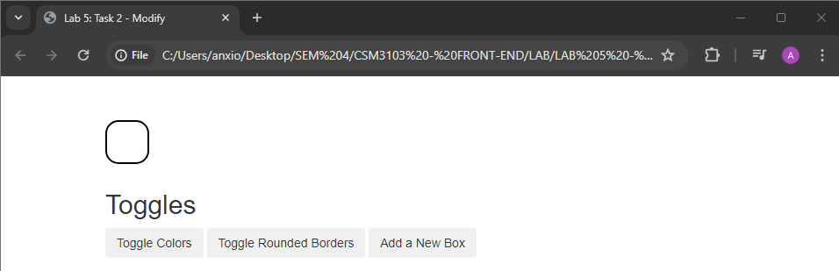

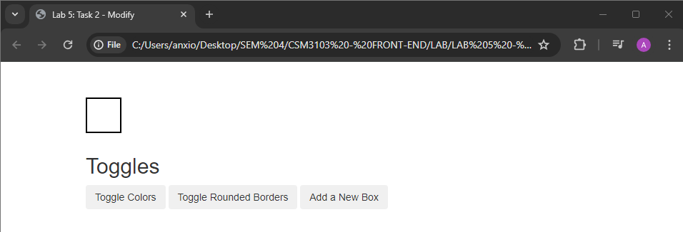

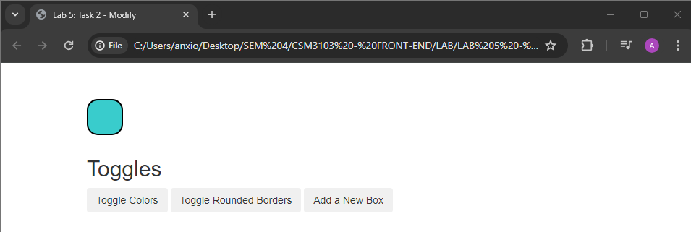

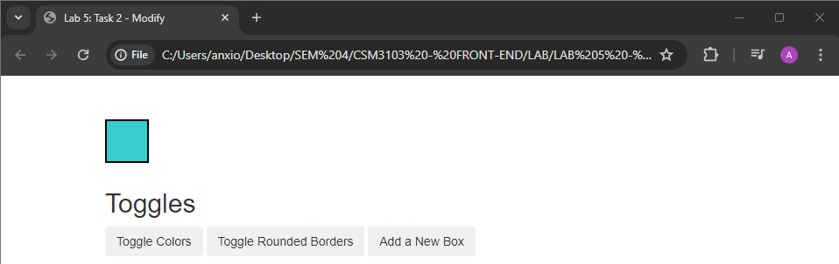

**Task 3**

Code :

|  |
| --- |
| <!doctype html>  <html>  <head>  <title>Lab 5: Task 3</title>  <meta charset="utf-8">  <script  src="https://code.jquery.com/jquery-3.1.1.js"  integrity="sha256-16cdPddA6VdVInumRGo6IbivbERE8p7CQR3HzTBuELA="  crossorigin="anonymous"></script>  <script  src="https://code.jquery.com/ui/1.12.1/jquery-ui.js"  integrity="sha256-T0Vest3yCU7pafRw9r+settMBX6JkKN06dqBnpQ8d30="  crossorigin="anonymous"></script>  <link rel="stylesheet" href=  "https://cdnjs.cloudflare.com/ajax/libs/normalize/5.0.0/normalize.css">  <link rel="stylesheet" href=  "https://code.jquery.com/ui/1.12.1/themes/ui-lightness/jquery-ui.css">  <style>  body {  margin: 20px;  }  #name_input {  float: left;  margin-bottom: 20px;  margin-right: 20px;  }  #date_input {  float: left;  margin-bottom: 20px;  }  #year_input {  clear:both;  }  .rank_color {  width: 20px;  margin-top: 2px;  }  #selectable .ui-selecting{  background: #FECA40;  }  #selectable .ui-selecting{  background: #F39814;  color: white;  }  #selectable li:before{  content: "\2713";  color:transparent;  }  #selectable li.ui-selecting:before{  content: "\2713";  color:black;  }  #selectable li.ui-selected:before{  content: "\2713";  color:white;  }  #selectable{  list-style-type: none;  margin: 0;  padding: 0;  width: 3px;  cursor: pointer;  }  #selectable li{  margin: 3px;  padding: 0.4em;  font-size: 1.0em;  height: 16px;  }  #sortable{  list-style-type: none;  margin: 0;  padding: 0;  width: 150px;  }  #sortable li{  margin: 0 3px 3px 3px;  padding: 0.4em;  padding-left: 1.5em;  font-size: 1.0em;  height: 12px;  }  </style>  <script>  $(document).ready(function() {  $('#date').datepicker();  $("#selectable").selectable();  $("#sortable").sortable();  $("#sortable").disableSelection();  $(document).tooltip({  item: '[title], [class]',  position: {my: "left center", at: "right center"},  content: function(){  var element = $(this);  if(element.is('[title]')){  return element.attr('title');  }  if (element.is('[class]')){  console.log('class', element);  if (element.hasClass('ui-state-default')){  var text = element.text();  return '<div class="color_switch" style="background:' + text +'"></div>'  }  }  }  })  });  </script>  </head>  <body>  <h2>jQuery UI-Survey</h2>  <h3>General Information</h3>  <div id="name_input">  <label for="name">Name:</label>  <input type="text" id="name">  </div>  <div id="date_input">  <label for="date">Date:</label>  <input type="text" id="date">  </div>  <div id="year_input">  <h3>Are you enrolled as an undergraduate or a graduate?</h3>    <input type="radio" name="enroll_year" id="ugrad" value="ugrad">  <label for="ugrad">Undergraduate (taking 6.813)</label><br>  <input type="radio" name="enroll_year" id="grad" value="grad">  <label for="grad">Graduate (taking 6.831)</label>    <!-- Step 2: Your HTML here -->  <ol id="selectable">  <li class="ui-widget-content" title="taking 6.813">Undergraduate</lI>  <li class="ui-widget-content" title="taking 6.813">Graduate</li>  </ol>    </div>  <div id="color_input">  <!-- Comment out instruction when you finish step 3 -->  <h3>Rank the colors listed from your most favorite (1)  to your least favorite (5). Be sure to only use each ranking once.</h3>  <!-- Comment this part of the form out after step 3 -->  <input type="text" class="rank_color" id="red">  <label for="red">#ff0000</label><br/>  <input type="text" class="rank_color" id="blue">  <label for="blue">#0000ff</label><br/>  <input type="text" class="rank_color" id="hot_pink">  <label for="hot_pink">#ff00b3</label><br/>  <input type="text" class="rank_color" id="mustard">  <label for="mustard">#ded447</label><br/>  <input type="text" class="rank_color" id="dark_green">  <label for="dark_green">#125e18</label><br/>  <!-- Step 3: Your HTML here -->  <span class="ui-icon ui-icon-arrowthick-2-n-s"></span>  <ul id = "sortable">  <li class = "ui-state-default">#ff0000</li>  <li class = "ui-state-default">#0000ff</li>  <li class = "ui-state-default">#ff00b3</li>  <li class = "ui-state-default">#ded447</li>  <li class = "ui-state-default">#125e18</li>  </ul>  </div>  </body>  </html> |

Output :

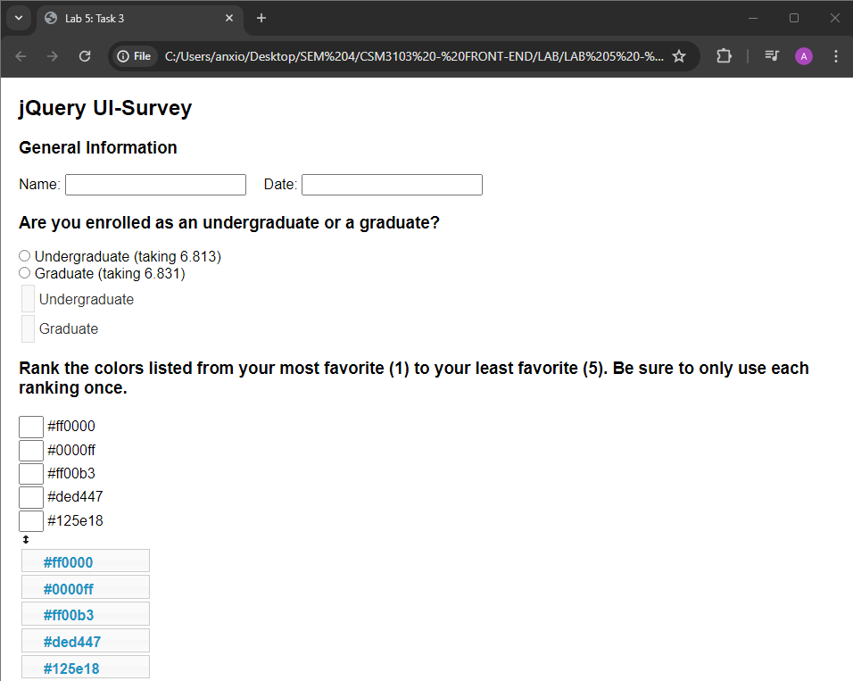

**Task 4**

Code :

|  |
| --- |
| <!doctype html>  <html>  <head>  <title>Lab 5: Task 4</title>  <meta charset="utf-8">  <script  src="https://code.jquery.com/jquery-3.1.1.js"  integrity="sha256-16cdPddA6VdVInumRGo6IbivbERE8p7CQR3HzTBuELA="  crossorigin="anonymous"></script>  <script  src="https://code.jquery.com/ui/1.12.1/jquery-ui.js"  integrity="sha256-T0Vest3yCU7pafRw9r+settMBX6JkKN06dqBnpQ8d30="  crossorigin="anonymous"></script>  <link rel="stylesheet" href=  "https://cdnjs.cloudflare.com/ajax/libs/normalize/5.0.0/normalize.css">  <link rel="stylesheet" href=  "https://code.jquery.com/ui/1.12.1/themes/ui-lightness/jquery-ui.css">  <style>  body { margin: 20px; }  #container { display: block; }  #draw_buttons { float: left; width: 100%; margin-top: 10px; }  </style>  <script>  $(document).ready(function() {  /* Step 1: Your code goes here */  var canvas = document.getElementById("myCanvas");  var ctxt = canvas.getContext('2d');  /* Step 2: Your js code goes here */  $("#button_draw_triangle").click(function() {  ctxt.fillStyle = '#f00';  ctxt.strokeStyle = '#000';  ctxt.lineWidth = 3;  ctxt.beginPath();  ctxt.moveTo(60, 240);  ctxt.lineTo(240, 240);  ctxt.lineTo(150, 60);  ctxt.closePath();  ctxt.fill();  ctxt.stroke();  });  /* Step 3: Your js code goes here */  $("#button_draw_rotated_triangle").click(function() {  ctxt.translate(canvas.width / 2, canvas.height / 2);  ctxt.rotate(Math.PI / 4);  ctxt.beginPath();  ctxt.moveTo(-90, 90);  ctxt.lineTo(90, 90);  ctxt.lineTo(0, -90);  ctxt.closePath();  ctxt.fill();  ctxt.stroke();  });  /* Step 4: Your js code goes here */  $("#button_clear_canvas").click(function() {  /* Clear canvas and reset transformations */  ctxt.clearRect(0, 0, canvas.width, canvas.height);  ctxt.setTransform(1, 0, 0, 1, 0, 0); // Reset transformation matrix  });  });  </script>  </head>  <body>  <h2>Manipulate the Canvas</h2>  <canvas id="myCanvas"  width="300" height="300"  style="border:1px solid #000000;"></canvas>  <div id="draw_buttons">  <button id="button_draw_triangle">Draw Triangle</button>  <button id="button_draw_rotated_triangle">Draw Rotated Triangle</button>  <button id="button_clear_canvas">Clear Canvas</button>  </div>  </body>  </html> |

Output :

Draw Triangle

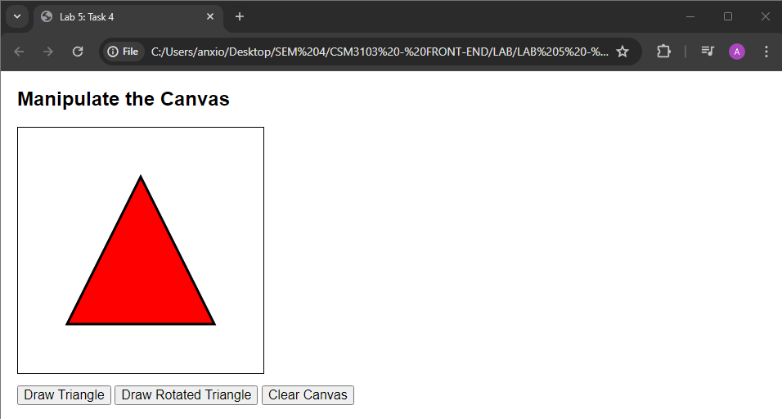

Draw Rotated Triangle

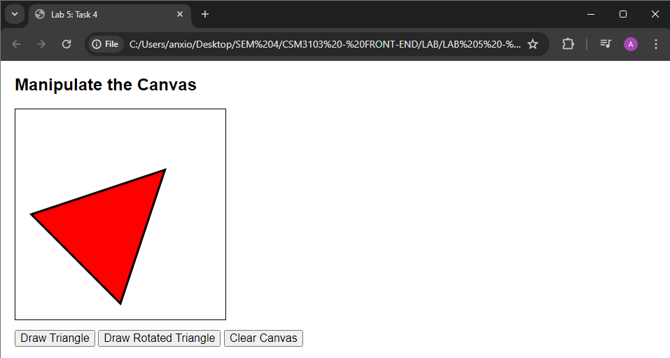

Clear Canvas

